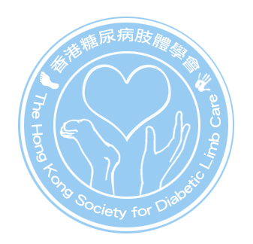

香港糖尿病肢體學會
The Hong Kong Society for Diabetic Limb Care Limited

Notice of The Annual General Meeting
On Wednesday 1st June 2016

NOTICE IS HEREBY GIVEN that the Annual General Meeting of The Hong Kong Society for Diabetic Limb Care Limited will be held on Wednesday 1st June 2016 at 6:30 pm at Conference Room , Ground Floor, AB Block, Queen Mary Hospital, 102 Pokfulam Road, Pokfulam, Hong Kong.

Agenda

1. To elect council members for the tenure 1st July 2016 to 30th June 2018;

2. To appoint auditor for providing audit service for the period 1st July 2014 to 30th June 2015

3. To consider any other business of the Society

Fung Yim-fong
Honorary Secretary
The Hong Kong Society for Diabetic Limb Care Limited
3rd May 2016

